Application Screenshots:

Home page:

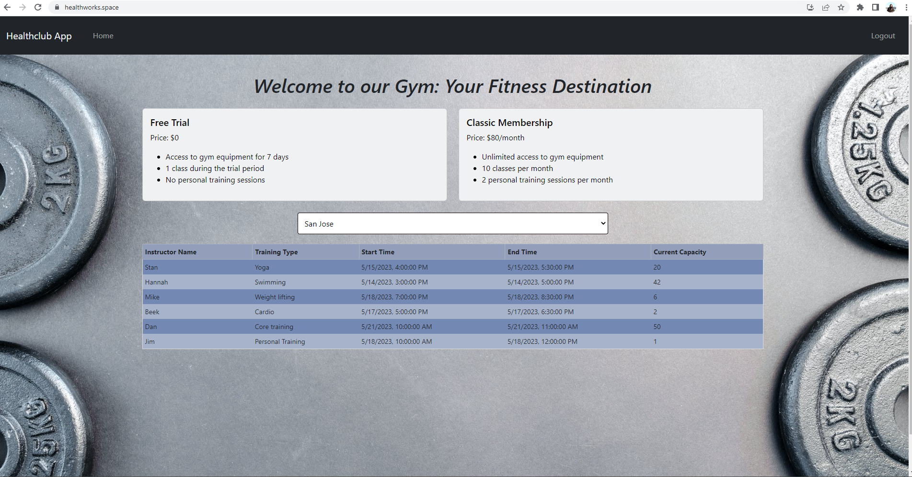

Login page:

Dashboard(Enrollment statistics):

Checkin/Checkout Page:

Manage Users:

Add trainings:

Signup Page:

Enroll members and nonmembers:

Equipment usage statistics:

Visitor count dashboard:

Hours spent in the gym:

Member Home:

Enroll page:

Log hours:

View activities:

